Friday 6th May 2022
Although it has been a short week (I do hope you have had a good BH weekend) we have managed to fit a lot in. The children have been working really hard and I have seen some examples of excellent work across the school. Unfortunately, some children have been off school with Covid this week and two of our staff, Mrs Houlden and Miss Scarlet. We wish everyone a speedy recovery.
Our Year 6 children have their end of Key Stage 2 assessments next week. They have worked hard to be the best they can be next week and we know they will ‘shine’. I know you will want to join us in wishing them good luck and much success. We will be having a special SATs breakfast every morning to prepare them to calmly face the day ahead.

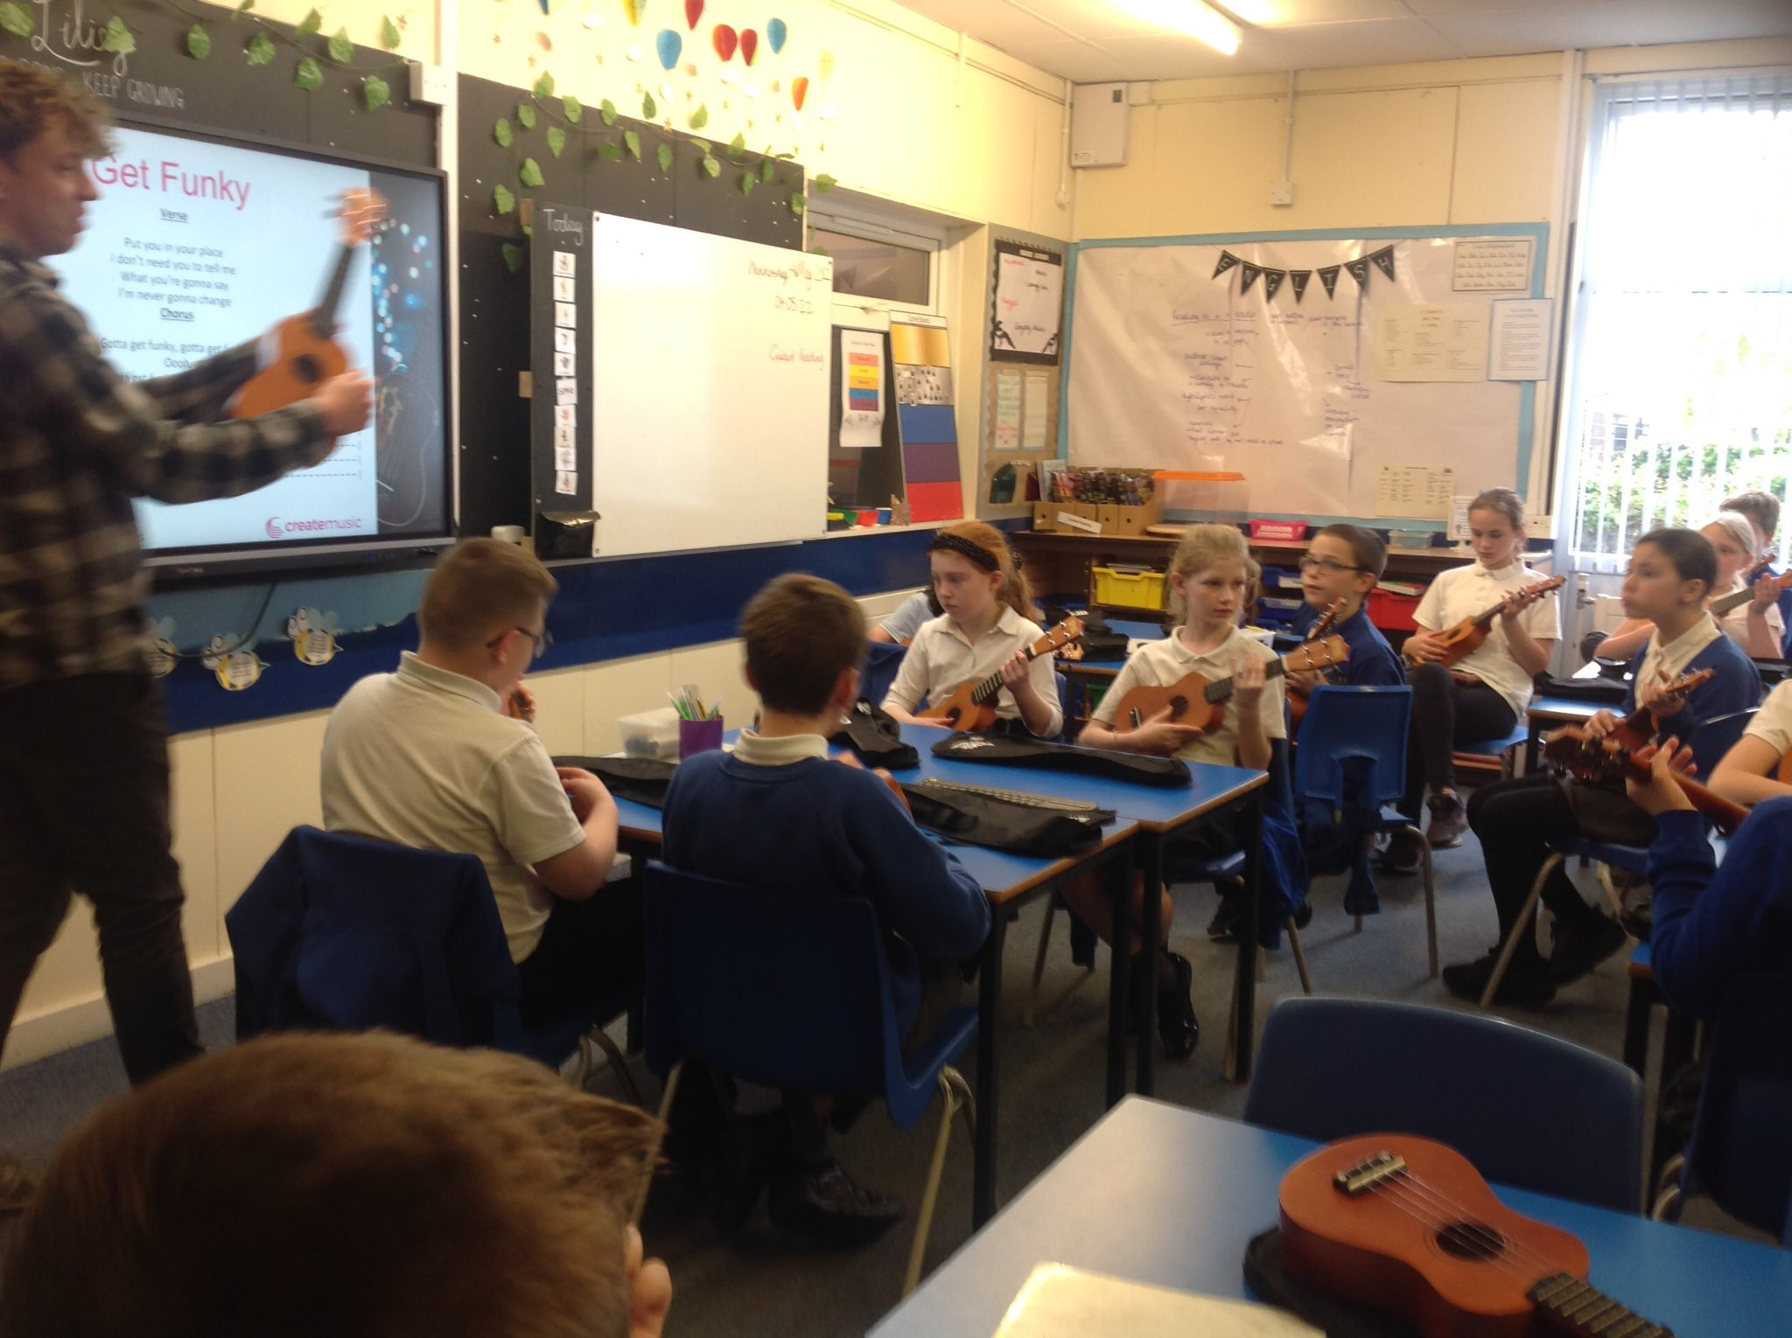
Guitar lessons
The children who requested a trial guitar lesson had them on Wednesday. The company delivering the lessons will be in touch. The children enjoyed the lesson as did Lillies class who are learning to play the ukulele. We are hoping they will perform at our summer fair….No pressure Lilies

Platinum Jubilee
In honour of the Queen’s Platinum Jubilee we are inviting children and staff to wear Red, White and Blue on Thursday 26th May. We will spend the day exploring the seven decades Queen Elizabeth has sat on the throne.
We have a special lunch planned from the kitchen that we hope many of our children will sign up to and we will be inviting Sunflowers children to join us on that day.
We will be decorating the hall and there will be some flag waving and music throughout the day.

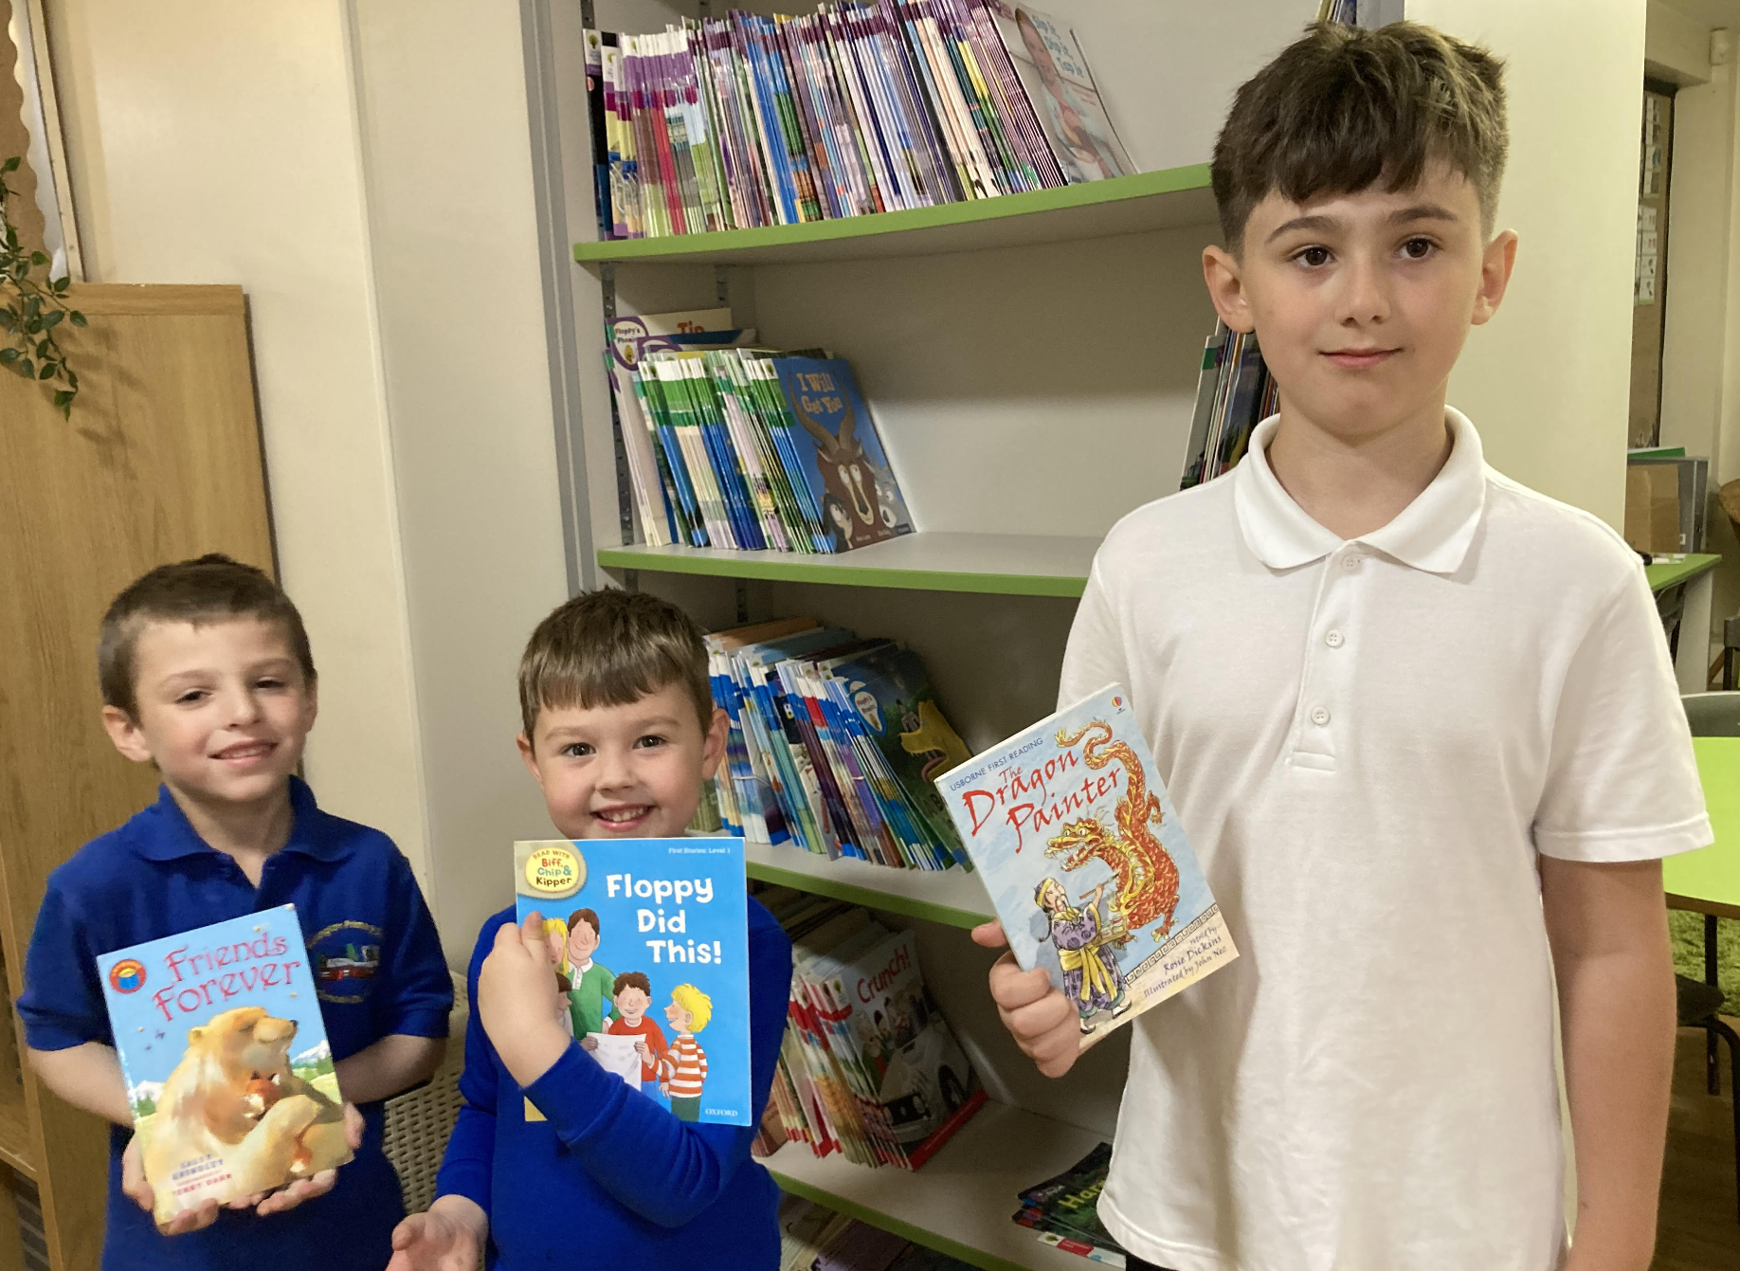
Reading
This week another three children received their book from our book vending machine (Logan O, Brax and Oliver M) Tulips winner to be announced on Monday. If your child reads to you or has read independently and this activity has been recorded signed by an adult in the child's reading record x 4 times during the week their names will be put into a hat to be drawn to receive a book from the vending machine. Happy reading
PTA
Our PTA will be selling ice lollies at the end of school on a Friday (potentially Thursday 26th May as we are not here on the 27th). They will stand outside the car park gates and the lollies are 50p. We will let you know if they are not going to be there.
On Saturday 16th July between 11am -2pm they will be running Kellington School Summer Fair. They have lots of exciting plans which we will be sharing with you shortly however please save the date. We are hoping we have a good turn out and the invitation to attend is open to our wider school community, within the villages our school serves and our children’s family and friends.
If you have any ideas, suggestions or wish to get involved and help beforehand or on the day please contact the PTA through their facebook page or the school office. Also if you or anyone you know would like to have a stall at this event, let them know. We are hoping for fine weather and a real community event with entertainment, food, stalls and lots of activities for the children.
Summer uniform
As the warmer weather approaches please can we ask that you always send your child to school with a coat, so they are not caught out when we get a summer shower.
We are happy for school uniform summer dresses to be worn or grey shorts as the days warm up, should children wish. Please could children also bring their water bottle to school each day and a sun hat to protect them when the temperature increases. Please can you also apply sunscreen at the start of the day so children are protected throughout the day. If your child
needs to reapply their sunscreen throughout the day please speak to your child’s class teacher

School Meals
Thank you to those of you who, following our correspondence, are now choosing their child’s school meal. Please can we ask everyone to pre order their child’s school dinner on Parentpay? As we have explained we have this system in place to support your child to choose a school dinner they are going to enjoy. The choice can be done up to 3 weeks in advance and up to 8am on the day of the meal. Our younger children especially find it difficult to make a choice from the pictures during school registration in the morning and whilst the adults in the classroom are available to help, unlike you, we do not know what your child does or does not like.
If you need any help with accessing the meal selector on ParentPay please speak to your child’s class teacher or the school office. By choosing your child’s school meal it means we can confidently encourage them to eat what they have chosen as we know it is something they like and also, as the register can take quite a while if children haven’t pre chosen their meal, we have more time for learning. Many thanks.
Covid 19
Unfortunately we have had a few cases of Covid within school this week. We do hope that everyone gets better soon. Please, if your child shows any signs of the covid virus (A new, continuous cough, or a high temperature, or a loss of, or change in, their normal sense of taste or smell) it is important that they do not attend school, as with any other illnesses, until they are well.
Uniform etc
Please do remember to label all parts of your child’s school uniform including PE kit, coats and hats. It is our school policy that long hair should be tied up for school and definately during PE. School shoes should be plain black shoes or boots, not trainers please, unless there are mitigating circumstances that have been discussed with school. Earrings need to be removed for PE (including swimming). Please speak to the school office if your child has just had their ears pierced so a suitable length of time can be agreed for when the need to remain in situ and the protocol explained. No jewelry should be worn for school, except a watch or small plain stud earrings please. Can we also ask that nail varnish is also removed for school. Many thanks for your co- operation

Rachael Lattimore
At the end of this half term Rachael Lattimore, our Learning Mentor will be leaving KPS to take up the post of Elective Home Education (EHE) Advisor for the Selby area. We will truly miss Rachael at KPS, however our congratulations go to her on this appointment and we wish her well in her new role. Whilst we will not be appointing into this role until September, we will continue to support our children and families and continue the work Rachael has been undertaking with our existing ‘Team Kellington’ staff.

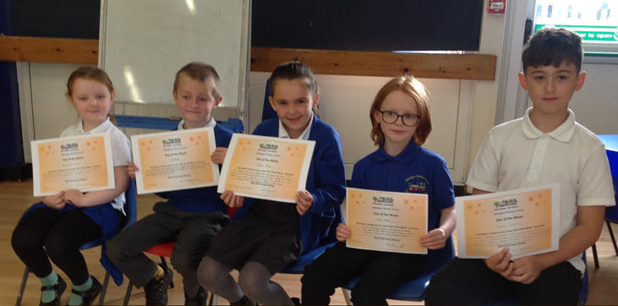
STARS OF THE WEEK
Sunflowers - Frankie
Daffodils - Frantisek

Roses - Amber
Tulips - Finan
Lilies - Logan O

Houses
The winning House this week is Manor

Boxes please
Daffodils and Roses classes need boxes for a science project. Shoe boxes, egg boxes, cereal
boxes etc are perfect. Any donations are greatly appreciated. Thank you

Attendance
Please continue to ensure that your child comes to school everyday that they possibly can. We are working extremely hard to enable all the children to not be disadvantaged by their lost learning due to the issues over the last 18 months and therefore they need to be here, in school, for us to be able to support them to be the best they can be .
Please can I remind everyone to inform us promptly if your child is absent from school, we do need a message via telephone or email as early as possible, by 9.30 am at the latest, however sooner is preferable. If we do not hear from you we have a duty of care to make contact to establish where your child is. We will keep ringing you until we get a reply. If we don’t get a reply we could have to report your child as a missing child.
We know this is sometimes difficult but whenever possible please try and make any appointments outside of school hours, or at the beginning or end of the school day.
Attendance this week - a real dip however a lot of illness this week.
Lilies 89.13 % Tulips 89.17 % Roses 90.95 % Daffodils 84.52 % Overall 88.71 %
We need children to be in school everyday they possibly can please. Please do not take your child out of school unless it is absolutely necessary. Everyday of learning that they miss is vital to their education journey, it is often hard for many children to catch up.
Free School Meals
If you think you may be entitled to Free School Meals please do contact the school for further information on how to check your eligibility and apply. Even if your child is in KS1 and is currently receiving a universal free school meal, if you are eligible for FSM it is really important that you apply, as there are still additional benefits for your child,

Dates for the Diary
Monday 9th- Thursday 12th May - Year 6 SATs week
Thursday 12th May 5pm - How we teach Phonics and Reading at Kellington Primary School. All Year 1 and Reception parents are invited to one of the sessions. We look forward to seeing you there.
Friday 13th May - Year 6- End of SATs sleepover
Thursday 26th May - Celebration of the Platinum Jubilee. Wearing of; Red, White and Blue and looking back over what has happened in our World over the last 70 Years and a special lunch that Sunflower children are invited to attend.
Thursday 26th May - School closes for May half term holiday
Friday 27th May - Inset day -School closed to children
Monday 6th June - School reopens for the final half term of the academic year. Friday 17th June 2pm- Sports day (Sunflowers 11am)
Wednesday 22nd June 2pm - Reserve Sports day (Sunflowers 11am)
Friday 24th June - Daffodils’ Class Assembly - 9am Parents welcome Change of date. Friday 1st July - Roses’ Class Assembly - 9am Parents welcome
Week commencing 4th July Specific activities for Year 6 children - details to follow (change of date due to transition week for some children)
Saturday 16th July 11am-2pm Kellington PTA School Summer Fair Please come and support us.
Tuesday 19th July - 2pm and 6pm Lilies end of year production
Friday 22nd July
9am End of year assembly
3.15pm School closes for summer holidays
Tuesday 6th September - School reopens

I do hope you have a lovely weekend and have some special family time
Take care, kind regards
Helen Humphrys Headteacher.

