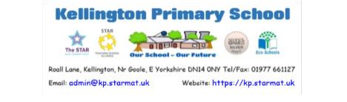Friday 24th June 2022
After our successful sports activities last Friday, thank you to all of you who attended and supported the children, we have had another busy week at Kellington Primary School, with lots of good work being completed and many children attending sporting tournaments too.
On Monday evening we held our Welcome Meeting for the new starters to Reception in September 2022. It was lovely to meet the families whose children will start or continue their education with Team Kellington, next academic year.
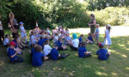
On Wednesday Daffodils and Roses class went for a tour around Kellington
Village as part of their geography learning focus. Although it was a very hot
afternoon, they enjoyed exploring their local community
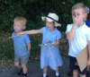
and were treated to lots of local knowledge imparted by
Mrs Maguire, one of our teaching assistants.
On Thursday a group of children from Year 4,5 and 6 attended a day of Kwik Cricket at Church Fenton Cricket ground. They had a great, but very warm day with apparently lots of excellent bowling and batting. Apparently we took a few wickets, hit some 4s and 6s and some catches. Well done to the children who attended, you were a credit to the school and thank you to Mrs Calam for both supporting you on the day and the practise leading up to the event. Thank you also to Mr Ayers for transporting children to the event and supporting the day.
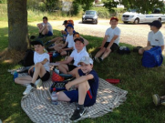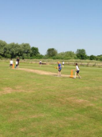
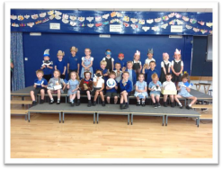
Today parents of the children in Daffodils’ class had
the pleasure of attending the class assembly. The
children were amazing and definitely all ‘shone’ and
were little superstars. Each and every one of them
took part and showcased the wonderful work they
have been undertaking recently.
We have also had fourteen boys and girls from
Lilies’ class taking part in a STAR MAT Primary
School Football Tournament today. We are sure that
they will have had a good day and have done their
best. We await their return to hear of their
successes.
PTA
Our PTA will be selling ice lollies at the end of school today and subsequent Fridays until the end of the summer term. They will stand outside the car park gates and the lollies are 50p. We will let you know if they are not going to be there.
On Saturday 16th July between 11am -2pm they will be running Kellington School Summer Celebration. They have lots of exciting plans which we will be sharing with you at the end of June however please save the date. The invitation to attend the celebration is open to our wider school community, within the villages our school serves and our children’s family and friends.
If you have any ideas, suggestions or wish to get involved and help beforehand or on the day please contact the PTA through their facebook page or the school office. Also if you or anyone you know would like to have a stall at this event, let them know. We are hoping for fine weather and to create a community event with entertainment, food, stalls and lots of activities for the children.
Summer uniform
As the warmer weather approaches please can we ask that you always send your child to school with a coat, so they are not caught out when we get a summer shower.
We are happy for school uniform summer dresses to be worn or grey shorts as the days warm up, should children wish. Please could children also bring their water bottle to school each day and a sun hat to protect them when the temperature increases. Please can you also apply sunscreen at the start of the day so children are protected throughout the day. If your child needs to reapply their sunscreen throughout the day please speak to your child’s class teacher
Covid 19 and other illnesses.
Please, if your child shows any signs of the covid virus (A new, continuous cough, or a high temperature, or a loss of, or change in, their normal sense of taste or smell) it is important that they do not attend school, as with any other illnesses, until they are well. We have had a couple of cases within school.

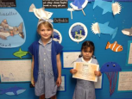
STARS OF THE WEEK
Sunflowers - Carly
Daffodils - The whole class!
Roses - Holly
Tulips - Charlie
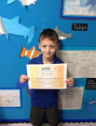
Lilies - Arseniy
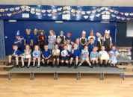

Houses
The winning House this week is Roall
Reading
This week, Tia, Evie and Reggie had recorded that they had read at least x5 during the week and their name was chosen from the hat to receive a book from the vending machine. Last week, Thomas also recorded these 5 reads. Well done!
If your child reads to you or has read independently and this activity has been recorded signed by an adult in the child's reading record x 5 times during the week their names will be put into a hat to be drawn to receive a book from the book vending machine.
Keep reading!
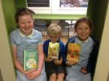
Holiday Club
Treetops Forest School Holiday Club
Weekly summer holiday camp held at Bishop Wood, Tuesday – Thursdays 9am 3pm 16th August 2022 – 1st Sept 2022.
Lots of free-play opportunities, rope swings, den building, fire lighting, games, tool use, campfire treats and much more.
For more information visit www.treetopsforestschool.co.uk or book a place via www.bookwhen/treetopsforestschool.
If you have any questions, please contact Siobhan Bamforth
treetopsforestschool@gmail.com
Music Tuition
Eggborough Music Lessons - Piano and Guitar
Free trial lesson - Contact Steve and Nicola 07794400987 www.eggboroughmusiclessons.co.uk
Attendance
Please continue to ensure that your child comes to school everyday that they possibly can. We are working extremely hard to enable all the children to not be disadvantaged by their lost learning due to the issues over the last 18 months and therefore they need to be here, in school, for us to be able to support them to be the best they can be .
Please can I remind everyone to inform us promptly if your child is absent from school, we do need a message via telephone or email as early as possible, by 9.30 am at the latest, however sooner is preferable. If we do not hear from you we have a duty of care to make contact to establish where your child is. We will keep ringing you until we get a reply. If we don’t get a reply we could have to report your child as a missing child.
We know this is sometimes difficult but whenever possible please try and make any appointments outside of school hours, or at the beginning or end of the school day.
Attendance this week -
Lilies 91.74% Tulips 87.10% Roses 92.67% Daffodils 89.58% Overall 90.19%
We need children to be in school everyday they possibly can please. Please do not take your child out of school unless it is absolutely necessary. Everyday of learning that they miss is vital to their education journey, it is often hard for many children to catch up.
If you take your child out of school we do need to know why and an absence form may be required and a meeting with Mrs Humphrys. Please speak to the office for clarification if you know your child is going to be absent.
Free School Meals
If you think you may be entitled to Free School Meals please do contact the school for further information on how to check your eligibility and apply. Even if your child is in KS1 and is currently receiving a universal free school meal, if you are eligible for FSM it is really important that you apply, as there are still additional benefits for your child.
Please see our school website https://kp.starmat.uk/ for any vacancies we have within school or the STARMAT website for local school vacancies https://web.starmat.uk/vacancies/
Dates for the Diary
Friday 1st July - Roses’ Class Assembly - 9am Parents welcome
Week commencing 4th July Specific activities for Year 6 children
Friday 15th July
Transition morning for the whole school - an opportunity for the children to meet their new teacher. PM - Reports home to parents
Saturday 16th July 11am-2pm Kellington PTA School Summer Celebration Please come and support us.
Tuesday 19th July - 2pm and 6pm Lilies end of year production
Friday 22nd July
9am End of year assembly
3.15pm School closes for summer holidays
Tuesday 6th September - School reopens for the children
Have a wonderful weekend and let’s hope the sun continues to
shine. Enjoy whatever you have planned and I look forward to
welcoming the children back on Monday for yet another busy
week.
Take care
Helen Humphrys
Headteacher

